**Banaras Hindu University**  
**Institute of Science**  
**Department of Computer Science**



**Subject: “Image Processing”**

**Submitted To:**  
**Dr.Ankita Vaish**  
Department of Computer Science

**Submitted By:**  
Sagar Timalsena

(24419MSC025)

**Academic Year:**

2024-2025

**Banaras Hindu University**  
**Institute of Science**  
**Department of Computer Science**



**Subject: “Image Processing”**

**Submitted To:**  
**Dr.Ankita Vaish**  
Department of Computer Science

**Submitted By:**  
Vikas Yadav

(24419MSC020)

**Academic Year:**

2024-2025

1. Load a color image.

Code:

|  |
| --- |
| *image = cv2.imread('Lena.png')*  *image* |

Output:

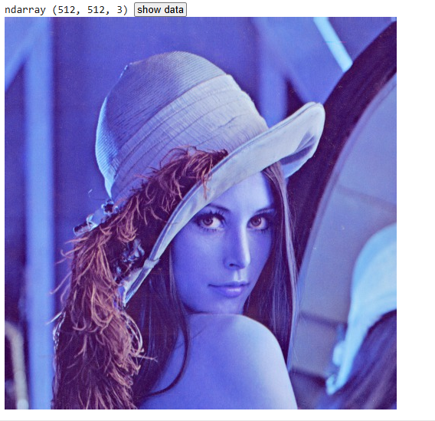

* Convert it into grayscale.

**Code:**

|  |
| --- |
| *gray_image = cv2.cvtColor(image, cv2.COLOR_BGR2GRAY)*  *gray_image* |

**Output:**

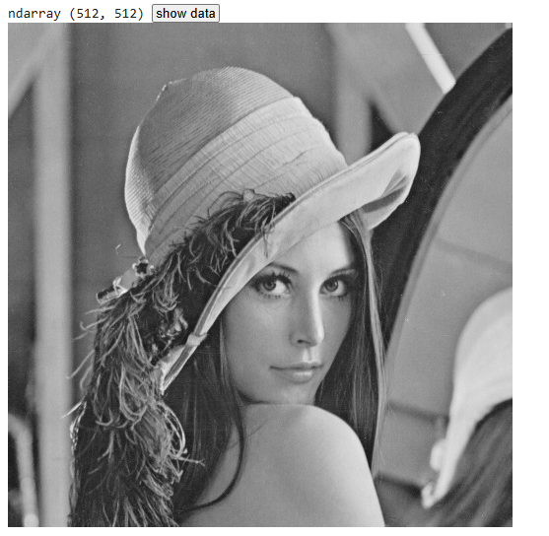

* Resize it into different dimensions (e.g. 128 *128 and 64*64).

**Code**

|  |
| --- |
| *resized_128 = cv2.resize(gray_image, (128, 128))*  *resized_64 = cv2.resize(gray_image, (64, 64))* |

* Display it into subplots

Code

|  |
| --- |
| *plt.figure(figsize=(6, 4))*  *plt.subplot(1, 2, 1)*  *plt.imshow(resized_128, cmap='gray')*  *plt.title("Grayscale 128x128")*  *plt.axis("off")*  *plt.subplot(1, 2, 2)*  *plt.imshow(resized_64, cmap='gray')*  *plt.title("Grayscale 64x64")*  *plt.axis("off")*  *plt.show()* |

**Output**

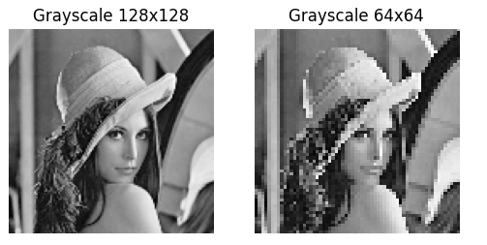

2.Create an image puzzle. Load the image you want to use and convert it to a NumPy array

ii. Divide the image into blocks of equal size. The size of the blocks will depend on how big you want your puzzle pieces to be.

**Code:**

|  |
| --- |
| *block_size = 64  # Define block size*  *blocks = []*  *indices = []*  *for i in range(0, resized_image.shape[0], block_size):*  *for j in range(0, resized_image.shape[1], block_size):*  *blocks.append(resized_image[i:i+block_size, j:j+block_size])*  *indices.append((i, j))* |

iii. Shuffle the order of the blocks to create a puzzle. You can do this by randomly permuting the indices of the blocks.

**Code:**

|  |
| --- |
| *shuffled_indices = np.random.permutation(len(blocks))*  *shuffled_blocks = [blocks[i] for i in shuffled_indices]* |

iv. Display the shuffled blocks as a puzzle by stitching them back together in their shuffled order.

**Code:**

|  |
| --- |
| *shuffled_indices = np.random.permutation(len(blocks))*  *shuffled_blocks = [blocks[i] for i in shuffled_indices]* |

v. To reconstruct the original image, unshuffled the blocks by applying the inverse permutation to the shuffled blocks and stitching them back together in their original order.

|  |
| --- |
| *original_image = np.zeros_like(resized_image)*  *inverse_permutation = np.argsort(shuffled_indices)*  *for idx, (i, j) in zip(inverse_permutation, indices):*  *original_image[i:i+block_size, j:j+block_size] = shuffled_blocks[idx]* |

vi. Store the permuted and reconstructed image.

**Code:**

|  |
| --- |
| *cv2.imwrite('shuffled_puzzle.jpg', shuffled_image)*  *cv2.imwrite('reconstructed_image.jpg', original_image)* |

**Final Output**

